Smart Vehicle Crash Detection System using IoT
Malampati Jai Durga Bhavani¹*, Mandadi Akshitha Reddy², Arutla Dhanush³, Singam Nihar Yadav⁴
durgamalampati06@gmail.com/* mandadiakshithareddy506@gmail.com/
arutladhanush1610@gmail.com/ yadavsingamnihar@gmail.com/
AI & ML Department, Sreyas Institute of Engineering and Technology, Hyderabad, India

Under the Guidance of
Dr G. Naga Rama Devi – Professor

Abstract
One of the fundamental motives for the deaths taking place global due to road accidents is the time required for providing clinical interest to the people worried in avenue accidents. The accident victims are typically not in a position to inform anybody about what and where they are. To correct this issue, a new system has been developed which is the Smart Vehicle Crash Detection System. Accelerometers and gyroscopes are special sensors that are used in this system to detect crashes or sudden movement. When an accident occurs, the system determines its location by use of GPS. It in turn transmits the location with a message to the family via a GSM device. It also has a cancel button which ensures that false alarms are avoided in case the car crashes against the road or accidentally brakes.
Keywords: Medical help, accelerometer, the gyroscope sensor, a GPS, GSM, and road accident are some of the words.

- Introduction

Road accidents have been one of the world’s biggest problems, claiming many lives. Recent research has shown that a lot of people end up dead at serious crashes due to reasons that don’t get medical help right away. A big problem is the people can’t talk to each other about what happened. Because of this absence of interaction, many individuals die, especially in areas in which treatment continues to be far away. There are should be way for people to automatically find out about an accident.

Numerous researchers have proposed divers systems for accident detection and alert transmission.[1] proposed a gadget for coincidence detection and actual-time region transmission utilising GPS generation. It is a helpful system for making the location-tracking features better, yet the issue of false alerts is still not fixed.[2] have written a thorough review of different incident detection systems and stressed how important it is to use communication technology.

[3] Event detection gadget which uses sensors to come across unexpected affects and speak
statistics to the person via communications module has been developed.

[4] developed an apparent-object accident detection system based on sensor data from motorcycles to improve monitoring through collision impact of the motorcycle operation. However, the sensor uses predetermined thresholds to detect events thus is subject to provide false identification of an event based upon some conditions.

A vehicle accident emergency alert system has been created [5] which sends an alerts message via GPS and GSM to people designated as recipients of the alerts. An alert messaging system was also developed by [6] which sends messages via GPS and GSM as well through sound devices (buzzers). The systems from both of these research projects provided a means for real time communication. However, they are limited to communicating only with family members and do not support communication with hospitals.

[7] they created a vehicle Tracking and Accident Notification system that uses GPS and GSM for real-time tracking of vehicles. However, [8] by providing a faster method of notifying authorities through their IoT motorcycle accident detection system. Furthermore, [9] developed a Smart Accident Detection System based on the Internet of Things (IoT), which would improve the efficiency of communicating with Emergency Services. Though all three systems demonstrate promise; however, there are still many challenges such false alarms, users having little or no control, and access to emergency healthcare services.

  - Motivation
Due to human mistake, poor road conditions, an increase in the number of transport vehicle, traffic accidents are rising quicky. The failure to provide prompt medical care is one of the main causes of the high death rate.

The goal of this project is to create an economical option to that will limit number of false alarms through the use of simple technologies as well as include a way to cancel false alarms by limiting unnecessary alert options. In addition, there is a functional goal to implement an entirely new option for providing ambulance services and individual families with detailed information about any incidents including where they occurred. Improving on all three of these components would enhance reliability, response time and valuable saving of life during an emergency.

1.2 Objectives

To provide police with innovative techniques for identifying and reporting on traffic problems so they can respond sooner because they will travel less during congested conditions before reaching the scene of the incident. When there is no congestion, there is a greater chance of saving lives as there are shorter response times for multiple agencies responding to the same scene. The mission’s number one goals are:

- To increase an automatic coincidence Detection Mechanism
- To Accurately Identify the Location of the Accident
- To Send Immediate Alerts to Family Members and Ambulance Services
- To Minimize False Alerts Using a User-Control Mechanism
- To layout a cost-effective and smooth-to-implement answer

  - Scope of the Project

The place of the proposed clever car Crash Detection system with the assist of the IoT
mainly focuses on enhancing road safety by allowing automated accident detection and fast
emergency communique. With the increasing number of vehicles and rising accident rates, there is a growing need for intelligent systems that can respond quickly during emergencies. This project aims to address these challenges by combining sensing, communication, and location tracking technologies into a single system.

Further expansion of the scope of this project is possible by including sophisticated technologies like cloud computing, mobile application development, and machine learning algorithms to improve the prediction of accidents as well as their analysis. This project could also be used in other vehicle types like automobiles, bicycles, and even in public transport systems.

In conclusion, this project seeks to develop an efficient and effective accident detection and alert system. By improving communication speed, reducing false alerts, and ensuring accurate location tracking, the system contributes to enhancing road safety and minimizing accident-related fatalities.

II. LITERATURE REVIEW

Earlier systems primarily aimed at the tracking of locations and alerts. As an example, [1] designed a GPS-based platform that gives the present position upon an accident. Although this enhances the accuracy of location, it does not entirely solve the problem of accurate detection of accidents. The review of the existing systems, provided by [2] indicated that despite the availability of a variety of solutions, more efficient and reliable systems are still needed.

The proposed sensor-based systems of [3] and IoT-based methods of [4] enhanced the level of automation by identifying instantaneous shift in vehicle movement. Nevertheless, such systems are based on the defined threshold values and can result in false alerts under some circumstances. Systems that are based on communication utilizing GPS and GSM like the ones created by [5] and [6] guarantee that the alert messages are delivered fast, however, they primarily inform family members and do not necessarily involve hospitals.

[7] and [8] added more features with the introduction of real-time tracking and monitoring features. These systems can improve the response time, however, still, they struggle with the issues of detection accuracy and false alarms. Recent systems suggested by [9] and. [10] are based on IoT and artificial intelligence to enhance detection. These systems are however more complex; they consume more computing power and cost more. The intelligent alert system that was developed by [11] also does not include features of user control, including the cancelation of the alerts.

The Smart Vehicle Crash Detection System with the help of the Internet of Things offered to address these shortcomings will allow accurate detection of accidents, minimizing false triggering by using a cancel button and guarantee that the alert messages are received by family members and hospitals located within the vicinity as well as the precise location of the accident. This enhances the system to be more reliable, efficient and to be more applicable in real life.

Table 1: Comparative Literature Review

Authors |  | Year | Methodology |  | Technology | Limitations
Butkar, Dinkar & Gandhewar |  | 2022 | GPS-based detection |  | GPS, GSM | No proper accident detection accuracy
Bari et al. |  | 2022 | Review Study |  | Various | No implementation
Gomathy et al. |  | 2022 | Sensor-based detection |  | Sensors, GSM | No verification of real accident
Rehman et al. |  | 2021 | IoT based system |  | Sensors, IoT | Depends on threshold values
Sumathy et al. |  | 2023 | Alert system |  | GPS, GSM | Hospital notification
Baballe |  | 2023 | Alert + buzzer system |  | GPS, GSM | No Smart decision making
Mounika et al. |  | 2021 | Tracking + alert |  | GPS, GSM | Limited features
Sevandal et al. |  | 2024 | IoT real-time system |  | IoT, Sensors | False alert issues
Babu et al. |  | 2023 | Smart IoT system |  | IoT communication | Complex system
Bhakat et al. |  | 2021 | AI-based system |  | IoT, AI | Costly and complex
Raffik et al. | 2021 |  |  | Intelligent alert system | Sensors, GSM | No false alert control

From the above, table1 presents a comparative evaluate of diverse research research carried out
inside the region of twist of fate detection and alert systems. It also highlights different methodologies that have been applied in the past, like GPS tracking, sensing technology, IoT systems, and artificial intelligence. The technology applied mainly includes GPS, GSM, sensing technology, and IoT communication technology.

III. PROPOSED SYSTEM

The proposed gadget is a smart vehicle Crash Detection device the usage of IoT that mechanically detects street injuries and sends emergency indicators with the exact place to own family participants and emergency services.

The device is designed to overcome the limitations of current methods with the aid of imparting fast, correct, and dependable coincidence detection in conjunction with real-time communique. It makes use of sensors ,a microcontroller, and verbal exchange modules to monitor the car continuously and reply without delay in case of an twist of fate.

On this gadget, accelerometer and gyroscope sensors are used to hit upon unexpected modifications in movement, effect, or tilt of the car. The magnitude is calculated as follows:

A = $\sqrt{{ b}_{x}^{2}+b_{y}^{2}+b_{z}^{2}}$
where $b_{x}$ , $b_{y}$ , $bz$ are the acceleration values from the sensor, A is the acceleration.

Those sensors constantly ship statistics to the ESP32 microcontroller, which techniques the facts and identifies whether or not an coincidence has happened based totally on predefined threshold values. If the acceleration is greater than the threshold value then an accident is detected.
For example: if A is greater than T then Accident Detected.
where T is the threshold value, like 3.5g.

Once a possible accident is detected, the system provides a short delay with a cancel button option. This permits the person to prevent the alert if it is a fake detection, which allows in reducing needless alerts. Time postpone for Cancel Button may be calculated as follows:
$$T=m×t$$
where n = number of loops, t = delay per loop

False alerts rate can be calculated as follows:
$Falsⅇ Alⅇrt ratⅇ=$ $\frac{Falsⅇ Alerts}{Total Alⅇrts}×100$

If the alert is not cancelled, the system activates the GPS module to obtain the exact location of the accident in terms of latitude and longitude. This location is then converted into a map link.
Area = (Latitude, Longitude)

The response time is calculated by adding the detection time and the GPS time and the GSM time.
$T_{res}=T_{det}+T_{GPS}+T_{GSM}$

Accuracy can be calculated using:
$Accuracy$= $\frac{corrⅇct\operatorname{Det}{ect}ⅈons}{⊤otal Tⅇsts}×100$

3.1 SYSTEM ARCHITECTURE

The smart vehicle Crash Detection machine based on the IoT consists of an incorporated architecture proven on figure1, which incorporates sensing, processing, and communication units to supply the precise detection of injuries and the reaction at the want to behave in case of an emergency.

The sensor records is sent to ESP32 microcontroller which is the middle unit of the machine. The controller receives the records and decides whether or not there's prevalence of an twist of fate or now not basing at the laid down situations. Once a possible accident has been detected the system waits a little of several seconds so that the user may cancel the alert with the aid of cancel button. This helps in minimization of false alerts.

The gadget will activate the GPS module to decide the exact region of the twist of fate in case the alarm isn't silenced. Such coordinates are converted to map link.

Thereafter, the GSM sends an alert record of the accident and the location to pre-defined contacts, consisting of family participants and local hospitals. this will make certain that resource is availed inside the accident area inside a brief time.

Figure 1: System Architecture

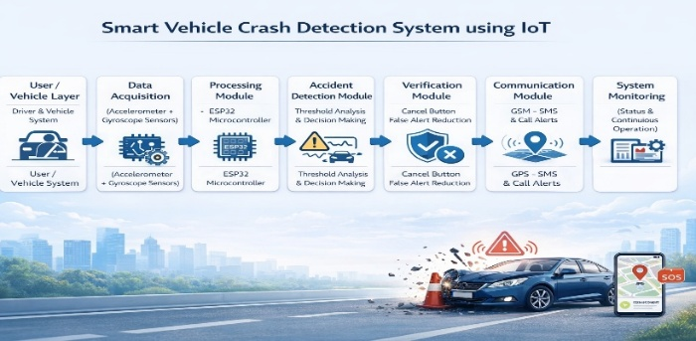

IV.METHODOLOGY

The methodology of the Smart Vehicle Crash Detection System using IoT explains the overall approach used to design, develop, and implement the system. This system is intended to automatically detect an accident and dispatched alerts with the geographical location. This system of operation can be divided into a few steps which are data gathering, processing, detection of accidents, validation and provision of alerts.
1. Data Collection
The collection of data is real time; this is done by use of sensors. The sensor is an accelerator and a gyroscope to detect the movements of the car and their speed and direction. The data is continuously collected and the values vary in various axes (X, Y, Z). The values are constant in normal conditions but upon an accident occurring, the sensor values are altered abruptly.

2. Data Processing
This phase includes real-time data processing by ESP32 microcontroller. It gets the information provided by the sensors and processes it to serve as an input to further processing.

3. Accident Detection
The processed data is then compared to preset threshold values at this point. When the value is more than the limit, then the process recognizes an accident in real time.

4. Verification (False Alert Reduction)
The system will wait a short time after the possible accidents have been detected and a user will be offered a choice to press the cancel button in case it is a false alarm. This measure will minimize false alerts caused by abrupt braking or adverse road conditions.

5. Location Tracking
In case of failure of the verification process, the system automatically switches on the GPS to obtain the present position of the vehicle. The coordinates of latitude and longitude are acquired here, and transformed into a map link.

6. Alert Generation
Having the location, the system switches the GSM Module and sends notifications about the accident and location to family members and hospitals in the vicinity.

7. Continuous Monitoring
The vehicle is continuously monitored because it re-initiates and begins to monitor the next accident.

V. IMPLEMENTATION

5.1 Software and Technology Stack

The smart car Crash Detection system is advanced the usage of a aggregate of software equipment and technologies that permit green data processing, communique, and real-time operation. the chosen generation stack guarantees easy interaction between hardware components and reliable machine overall performance.

Table 2: Technology Used in Proposed System

Components | Technology used | Version | Description
Programming Language | Embedded C | Standard | Core of the system Development
Micro Controller | ESP 32 | Latest | Data processing and control unit
Sensor Module | Accelerometer & Gyroscope | Latest | Detect motion, vibration and impact
Communication Protocol | 12C/SPI | Standard | Sensor data communication
GPS Module | NEO-6M GPS | Latest | Location tracking (latitude & longitude)
GSM Module | SIM800/SIM900 | Latest | Sending alert messages (SMS)
Data Processing | Threshold-based Logic | - | Accident detection decision making
Development Environment | ESP-IDF / Embedded Tool | Latest | Development and debugging
Debugging Tool | Serial Monitor | - | Real-time system monitoring
The table2 above shows the different technologies employed in the proposed Smart Vehicle Crash Detection System and their functions. Embedded C programming language is used to develop the system, and it serves as the core of the software, allowing it to effectively control the hardware components. The microcontroller ESP32 is the central processing unit, which processes the sensor data and operates the system as a whole.

5.2 Key Module Implementations
Smart Vehicle Crash Detection System is put in place by subdividing the system into functional modules. All modules have a particular task to be fulfilled, and their combination will guarantee proper accident detection and quick generation of alerts.

5.2.1 Sensor Data Acquisition Module
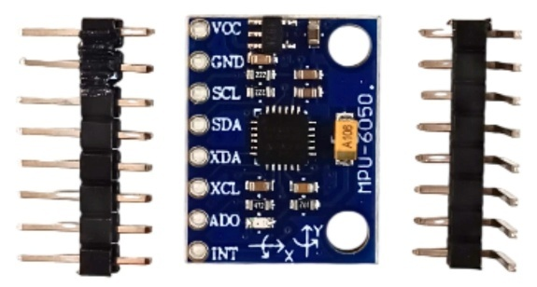
Figure 2: Sensor Module

The figure 2 will be charged with the responsibility of gathering real time information on the vehicle. Motion, vibration and orientation are measured with the accelerator and gyro sensor. These sensors keep transmitting data to the ESP32 microcontroller. The values are stable under normal circumstances but in case of an accident, they change suddenly.

5.2.2 Processing Module (ESP32)
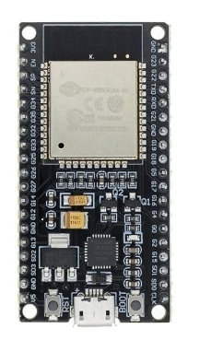
Figure 3: ESP32 Development Board
The figure 3 is the primary processing unit. It takes the information into consideration of the sensors and works on it in real-time. The controller sieves the data and then makes it ready to be analysed. It makes the system work without interruption and react promptly in case some abnormal conditions are identified.

5.2.3 Accident Detection Module
This module works through detecting accidents based on threshold. The sensor values processed are compared to predefined limits. When the values are greater than these limits, this system detects this as a potential accident. The technique is useful in identifying an abrupt impact or inappropriate movements in an effective manner.

5.2.4 Verification Module
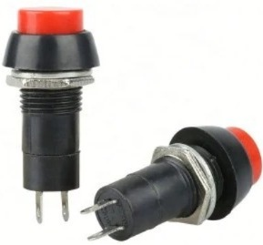
Figure 4: Cancel Button
In order to minimize false alert, a check procedure is added. A few seconds are allowed during which the system waits when a potential accident is identified. In the process, the user can use the cancel button in case of a false detection. In case the button is clicked the alert is terminated. Otherwise, the system goes to the next stage.

5.2.5 Location Tracking Module (GPS)
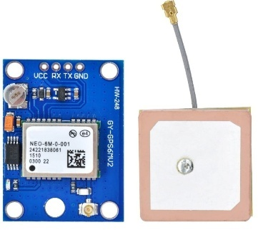
Figure 5: GPS Module

Once the accident has been confirmed, the GPS module is started. It gets the position of the vehicle that is in use (latitude, longitude). This information becomes crucial when it comes to determining the location of the accident and is subsequently forwarded to emergency contacts.

    - Communication Module (GSM)
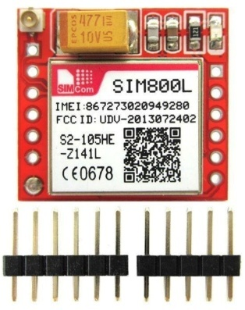
Figure 6: GSM Module
The number 6 is in charge of the alert messages. It is controlled by the ESP32 and transmits SMS notifications with information on accidents and location. This will make the message reach family members and the resulting hospitals within a short time.

5.2.7 Alert and Notification Module
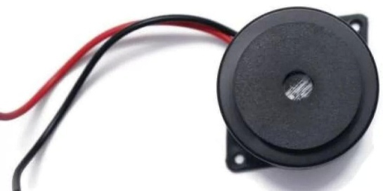
Figure 7: Buzzer

This module makes sure that the alert message is sent out in an appropriate manner. The system provides notifications to the predefined contacts and ensures a successful transmission of the message. This ends the emergency alert process.

5.2.8 System Monitoring Module
Once the alert has been sent, the system is rebooted and it resumes its monitoring. This module ensures perpetual functioning and makes the system ready to identify subsequent accidents.
5.3 System Deployment

The installation and operation of the Smart Vehicle Crash is called system deployment.
Detection System in a real-world environment. The deployment objective is to make sure that the system works properly within a vehicle, and is reliable when used in real-life driving.
conditions.

The system is implemented through the combination of all hardware devices, one of them being the ESP32 microcontroller, sensors, GPS module, GSM module and cancel button, into a small configuration. These parts are appropriately bonded with a PCB or a secured wiring to be stable.
during vehicle movement.

Generally, the deployment will make sure that the system is stable, reliable and in a position to work effectively in practice, in the case of emergency help in a timely manner.

VI. EXPERIMENTAL EVALUATION

6.1 Experimental Setup
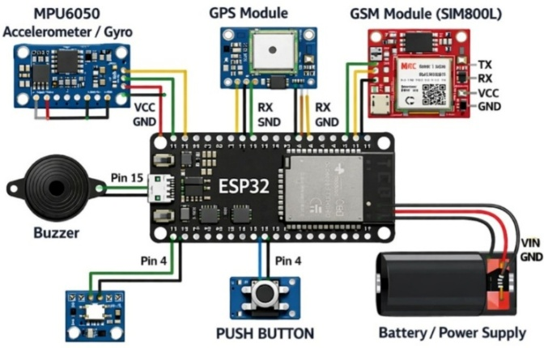

Figure 8: Working model
Based on the figure 8, the ESP32 microcontroller - its work connects the velocity gauge to the magnetometer, connects itself to a satellite component, joins to a GSM device, and then the cancel button. Power circulates consistently in all the parts with the help of a stable source, which keeps all working continuously as long as tests run.
Tabel 3: Experimental Configuration

Parameter | Specification
Programming Language | Embedded C
Development Environment | ESP-IDF
Operating System | Windows 11
Processor | Intel Core i5
RAM | 4 GB
System Type | IoT-Based Accident Detection System
Data Sources | Sensor Data (Accelerometer & Gyroscope)
File Formats | Serial Data
Communication Protocol | I2C, UART
GPS Module | NEO-6M
GSM Module | SIM800
Micro Controller | ESP 32
Sensors | Accelerometer
Iterations Per Test | Multiple test runs
Metrics Evaluated |  | Accuracy, Response Time, False Alert rate

The table3 above outlines the experimental set up to test and evaluate the Smart Vehicle.
Crash Detection System. The system is created with the help of the Embedded C programming language and run in the ESP-IDF development environment. The experiments are carried out on a window 11 Intel core i5 processor, with 4GB RAM, offers adequate development and testing facilities.
6.2 Performance Metrics

The performance analysis of the Smart Vehicle Crash Detection System is discussed.
system to evaluate its performance in the detection of accidents and false triggering and sending emergency messages in the real time mode. The system is also experimented in other scenarios that involve normal driving, sudden braking and simulated accidents.

Table 4: Performance Comparison

Module | Function | Latency(ms) | Through Put (logs/sec) | Accuracy (%) | Remarks
Sensor Data | Collect motion data from accelerometer | 20 | 300 | 100% | Continuous monitoring
Preprocessing | Filter noise and normalize sensor data | 35 | 250 | 98% | Improves detection quality
Accident Detection | Identify sudden impact | 40 | 220 | 92% | Core detection module
Decision Module | Verify accident using threshold logic | 25 | 260 | 90% | Reduce false alerts
Cancel Alert System | Allow user to cancel false alarms | 15 | 280 | 100% | Prevents unnecessary alerts
GPS Module | Fetch exact location | 50 | 180 | 95% | Accurate within 5-10 meters
GSM Module | Send alert message | 60 | 150 | 95% | Depends on network
System Integration | Coordinate all modules | 30 | 230 | 100% | Smooth Operation

The table2 above is the performance analysis of various modules of the Smart Vehicle crash Detection System. The modules are analyzed on the basis of parameters like vicinity, throughput, precision and general functionality. Latency and throughput of sensor data is very low and provides continuous monitoring of vehicle movement.
without delay.

6.3 Comparative System Analysis

The proposed clever automobile Crash Detection machine is more efficient in comparison to present systems because it gives real-time accident detection with accurate location monitoring. not like conventional systems, it consists of a cancel button to lessen false indicators. It also sends indicators to both circle of relatives participants and nearby hospitals, improving emergency response. ordinary, the machine is extra dependable, faster, and practical for real-international applications.

Table 5: Comparison with Existing System Approaches

Feature | Traditional Forensic Methods | Existing Systems | Proposed AI-Based system
Accident Detection | Manual | Sensor-Based | Automatic (Sensor +ESP 32)
Response Time | Slow | Moderate | Fast
Location Tracking | Not Available | Partial | Accurate (GPS + Map link)
Alert System | Manual calls | SMS to limited contacts | SMS to Family
False Alert Handling | Not Available | Limited | Cancel Button Feature
Automation Level | Low | Medium | High
Detection Method | Human Observation | Threshold-Based | Improved Threshold Logic
Accuracy | Low | Medium | High
Real-Time Monitoring | No | Limited | Yes
Communication | Manual | GSM-Based | GSM with faster response
System Cost | Low | Medium | Cost Effective
Reliability | Low | Medium | High

The table5 above is a comparison of traditional forensic method, current system to detect accidents, and our proposed system, the Smart Vehicle Crash Detection System.
The conventional means are largely based on manual reporting and human observation leading to slow response time and real-time monitoring. These means also lack automatic location tracking or alert system.

6.4 System Demonstration

The figure9 explains how the Smart Vehicle Crash Detection System works in real-time
conditions. The demonstration is implemented by connecting all the hardware such as the ESP32 microcontroller, the accelerator and gyro sensors, the GPS and the GSM module, etc.
buzzer, and cancel button.

The system continues to the next step unless the cancel button is pressed. The GPS module retrieves the current position of the vehicles; GSM module alerts the message with the accident information and the position link to pre-defined contacts like family members and ambulance services.

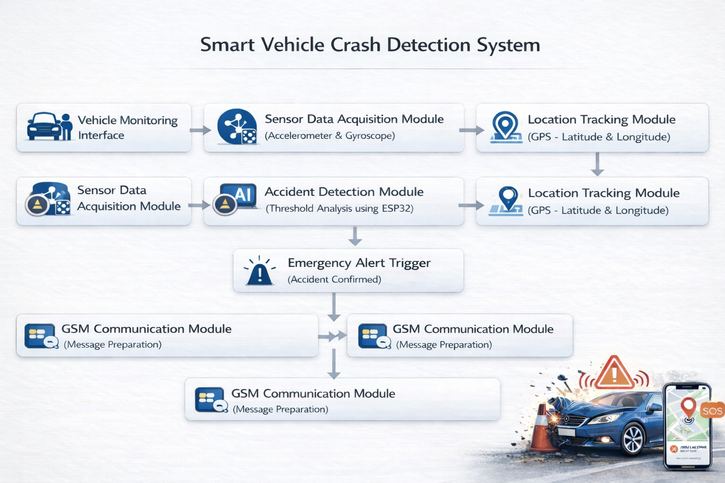
Figure 9: System Demonstration

VII. RESULT AND DISCUSSION

7.1 System Performance Summary
The IoT Smart Vehicle Crash Detection system was also tested in a variety of real-time to assess its functionality and effectiveness. The system was able to identify sudden impacts based on accelerator and gyroscopes sensor data and reacted fast to possible impact accident situations.
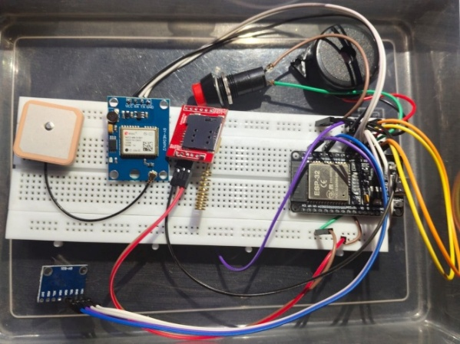

Figure 10: Model

Mostly the GPS module could give the location information, however, minor delays were also experienced when the signal strength was poor. In addition, the GSM module efficaciously sent alert messages to predefined contacts, however the shipping time various relying on network situations.
In general, the system showed good performance in real-time accuracy in accident detection and alert generation. It was very accurate, effective in communication and efficient operation.

7.2 Graphical Performance Analysis
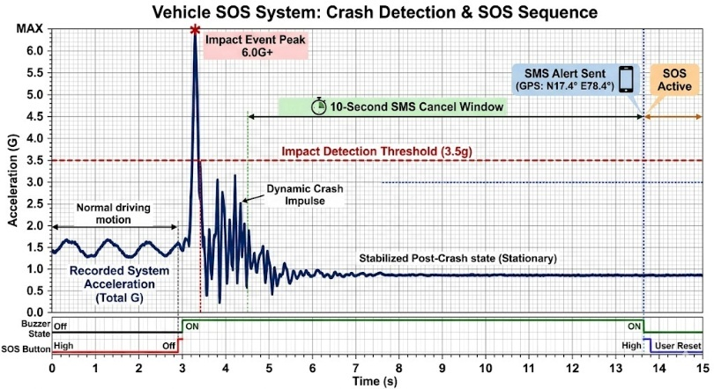
Figure 11: Illustration of Acceleration and Time

The figure11 shows a vehicle acceleration over time and showing a transition from Normal
motion.
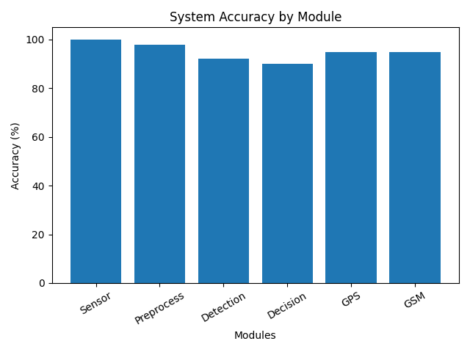
Figure 12: Accuracy

The figure 12 shows accuracy of the system.

VIII. APPLICATIONS

  - Applications
Smart Vehicle Crash Detection System based on IoT may be applied in different real-life situations to enhance safety and emergency response. It is extremely helpful in personal vehicles like cars and bikes, where it will automatically sense accidents and issue warnings when the driver is not able to communicate. The system is also applicable in commercial vehicles like taxis, buses, and delivery services. It helps fleet operators monitor vehicle safety and respond quickly in case of emergencies. In addition, it can be used by emergency services and hospitals to receive real-time accident information and reach the location faster.

IX. CONCLUSION

The Smart Vehicle Crash Detection System with the help of IoT is created to solve the serious issue of the slow response to an emergency in the case of the road accident. The system is capable of integrating the sensors, micro controller, GPS and GSM modules to automatically pick accidents and text out alert messages that include precise location information. The project has shown that real-time monitoring with the use of accelerator and gyroscope sensors can be effective to detect the abnormal conditions like the collision or the sudden impact. This data is processed with the help of ESP32 microcontroller and provides rapid decision-making.

To sum up, the suggested system offers an inexpensive, easy, and efficient way of detecting an accident and notifying of an emergency. It can easily be put to practice in actual vehicles and advanced technologies could be applied in the future.

X.REFERENCES

- Butkar, Umakant Dinkar, and Nisarg Gandhewar. "Accident Detection and Alert System (Current Location) Using Global Positioning System." Journal of Algebraic Statistics 13, no. 3 (2022).

- Bari, Abdulkadir Shehu, Muhammad Abubakar Falalu, Muhammad Auwal Umar, Yakubu Yunusa Sulaiman, A. M. Gamble, and M. A. Baballe. "Accident detection and alerting systems: A review." Global journal of research in engineering & computer (2022).

- Gomathy, C. K., K. Rohan, Bandi Mani Kiran Reddy, and V. Geetha. "Accident detection and alert system." Journal of Engineering, Computing & Architecture 12, no. 3 (2022): 32-43.

- Rehman, Saad Ur, Shaheryar Ahmad Khan, Arshia Arif, and Umar S. Khan. "IoT-based accident detection and emergency alert system for motorbikes." In 2021 International Conference on Artificial Intelligence and Mechatronics Systems (AIMS), pp. 1-5. IEEE, 2021.

- Sumathy, B., L. Sundari, S. Janani Priyadharshini, and G. Jayavarshini. "Vehicle accident emergency alert system." In IOP Conference Series: Materials Science and Engineering, vol. 1012, no. 1, p. 012042. IOP Publishing, 2021.

- Baballe, Muhammad Ahmad. "Accident detection system with gps, gsm, and buzzer." TMP Universal Journal of Research and Review Archives 2, no. 1 (2023): 28-36.

- Mounika, J., N. Charanjit, B. Saitharun, and B. Vashista. "Accident alert and vehicle tracking system using GPS and GSM." Asian Journal of Applied Science and Technology (AJAST) Volume 5 (2021): 81-89.

- Sevandal, Elamae B., Myla Fe T. Menque, Lovely Mae Dagsa, Alfred Dennis B. Balamad, and Edgardo Ricardo B. Sajonia Jr. "Real-time IoT-based motorcycle accident detection and alert system." International Exchange and Innovation Conference on Engineering & Sciences, 2024.

- Babu, CV Suresh, N. S. Akshayah, and R. Janapriyan. "IoT-based smart accident detection and alert system." In Handbook of research on deep learning techniques for cloud-based industrial IoT, pp. 322-337. IGI Global Scientific Publishing, 2023.

- Bhakat, Akash, Neetigya Chahar, and V. Vijayasherly. "Vehicle accident detection & alert system using IoT and artificial intelligence." In 2021 Asian conference on innovation in technology (ASIANCON), pp. 1-7. IEEE, 2021.

- Raffik, R., M. Michael Jones, T. Murugajothi, and B. Kannadasan. "Intelligent accident detection and smart alert system for vehicles." International Journal of Mechanical Engineering 6, no. 3 (2021): 2391-2396.

- Rahman, Mohammad Minhazur, AZM Tahmidul Kabir, Shoumic Zaman Khan, Nahin Akhtar, Abdullah Al Mamun, and Shah Mohammad Mahmud Hossain. "Smart vehicle management system for accident reduction by using sensors and an IoT based black box." In 2021 8th International Conference on Electrical Engineering, Computer Science and Informatics (EECSI), pp. 277-282. IEEE, 2021.

- Nandhu, Chinthamalla, Anumula Gopi, Banja Nithamdhar, Chelluboina Laxmiprasanna, Dangeti Srihari, A. Jitendra, and M. Saravanan. "IoT-based vehicle tracking with accident alert system." International Journal of Research Publications in Engineering, Technology and Management (IJRPETM) 9, no. 2 (2026): 486-494.

- Razali, Sharifah Nadiyah, Khyrina Airin Fariza Abu Samah, Mohd Hafiez Ahmad, and Lala Septem Riza. "IOT based accident detection and tracking system with telegram and SMS notifications." In 2021 6th IEEE International Conference on Recent Advances and Innovations in Engineering (ICRAIE), vol. 6, pp. 1-5. IEEE, 2021.

- Sahraei, Mohammad Ali, and Said Ramadhan Mubarak Al Mamari. "A review of Internet of Things approaches for vehicle accident detection and emergency notification." Sustainability 17, no. 14 (2025): 6510.

- Mehmood, Muhammad Rehan, Nadeem Iqbal Kajla, Malik Daler Ali Awan, Malik Muhammad Saad Missen, Muhammad Umar Chaudhry, and Amnah Firdous. "Accident Alert System of Vehicle and Life Security using IoT Devices and Image Processing." Journal of Computing & Biomedical Informatics 4, no. 01 (2022): 197-206.

- Alsayaydeh, Jamil Abedalrahim Jamil, Mohd Faizal bin Yusof, Mohamad Amirul Aliff Abdillah, Ahmed Jamal Abdullah bin Al-Gburi, Safarudin Gazali Herawan, and Andrii Oliinyk. "Enhancing Vehicle Safety: A Comprehensive Accident Detection and Alert System." International Journal of Advanced Computer Science & Applications 14, no. 11 (2023).

- Yellamma, Pachipala, N. S. N. S. P. Chandra, Puli Sukhesh, Puligadda Shrunith, and Sunkesula Siva Teja. "Arduino based vehicle accident alert system using GPS, GSM and MEMS accelerometer." In 2021 5th International Conference on Computing Methodologies and Communication (ICCMC), pp. 486-491. IEEE, 2021.

- Chinnasamy, P., Chintha Sivakrishnaiah, T. Sathiya, Irfan Alam, and Divya Priya Degala. "Design and Implementation of an IoT-based Emergency Alert and GPS Tracking System using MQTT and GSM/GPS Module." In 2025 5th International Conference on Trends in Material Science and Inventive Materials (ICTMIM), pp. 1286-1291. IEEE, 2025.

- Wategonkar, Somnath R., Kantilal P. Rane, Surekha A. Khot, Navin Ashok Yadav, Saish Anand Vilankar, and Shyam Akashe. "Development and execution of an IoT-based accident detection and Alert system with location tracking." In 2024 Sixth International Conference on Computational Intelligence and Communication Technologies (CCICT), pp. 91-97. IEEE, 2024.
- Tasgaonkar, Pankaj P., Rahul Dev Garg, and Pradeep Kumar Garg. "An IoT-based framework of vehicle accident detection for Smart City." IETE Journal of Research 70, no. 5 (2024): 4744-4757.

- Singh, Dinesh Kumar, Niraj Kumar Shukla, and Pavan Kumar Singh. "IoT-based vehicle tracking and accident alert system." In Intelligent Control for Modern Transportation Systems, pp. 63-75. CRC Press, 2023.

- Shubham, Suraj Pratap, Madan Kumar, and Sarika Jain. "A survey on IoT based automatic road accident detection." In 2021 5th international conference on intelligent computing and control systems (ICICCS), pp. 1-7. IEEE, 2021.

- Patel, Abhishek, Sanjeev Yadav, Aditya Kumar Yadav, Navneet Chaudhary, Archi Mishra, and Prabhakar Shrama. "IoT-Based Real-Time Accident Detection and Alert System." In 2025 3rd International Conference on IoT, Communication and Automation Technology (ICICAT), pp. 1-4. IEEE, 2025.

- Aminu Ya’u1, Muhammad Ahmad Baballe, Zainab Abdulkadir, Amina Ibrahim, Khadija Mahmoud Sani, and Shuaibu Bala Kasuwar Kuka. "A GSM, buzzer, and GPS module-based accident detection system: Design and Simulation.

